California State Polytechnic University, Pomona

Lab 2: 4x16 Decoder

Group F:

Danny Manzo, Bronco ID: 014451190

Maher Mateen, Bronco ID: 013891189

ECE 3101L – Signals and Systems Laboratory

Professor Mohamed Aly

20 June 2022

1. **How a Decoder Works:**

A decoder is a combinational logic circuit that converts a binary integer input to an associated binary output. The decoder we are programming has an enabled input which will enable or disable the decoder. We are using a 4x16 decoder for this experiment which has 4 binary inputs with an enable input and 16 different outputs. The decoder's main purpose in the real world is to convert a digital signal to an analog signal.

1. **How We Coded It:**

To code the 4x16 decoder, first we specified an input port with a length of 4 bits, which we named “a”, an input port with a length of 1 bit called “EN” to act as our enable, and an output port with a length of 16 bits called “F”. To make the length of each port to be longer than 1 bit, we checked the Bus column in the I/O Port Definitions and set the MSB to be bit 3 for input “a” and bit 15 for output “F”. Next, we used structural modeling to implement the 4x16 decoder using AND gates. We used 16 AND gates to have 16 different outputs to the 16-bit long port “F”. Our inputs for the AND gates were a combination of the 4 bits from input port “a”, with some of the input bits passing through a NOT gate before being passed to the AND gate, from the MSB to LSB, with the enable bit “EN” also being passed to the AND gate to ensure that there is only an output if the enable bit is high. To determine when to NOT each input bit, we used a truth table for the 4x16 decoder.



Figure 1: Truth Table of a 4x16 Decoder with Enable bit

1. **Vivado Data Collection:**

In Vivado, after running synthesis and report utilization, we found that the number of look-up tables (LUTs) used was 8 and there were 21 input/output bits (IOB). The total power of the 4x16 decoder was also reported to be 3.073 W.

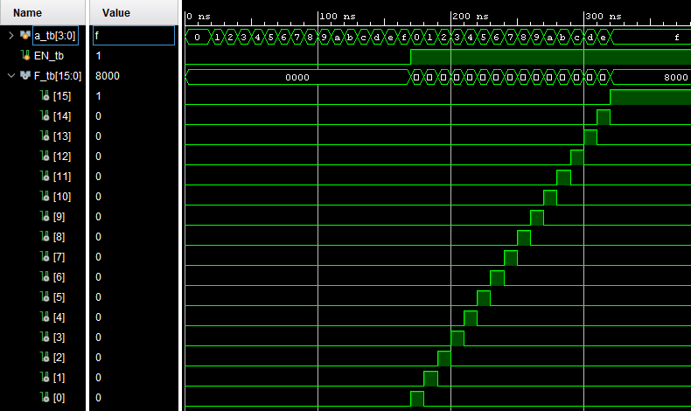

Figure 2: Testbench Results

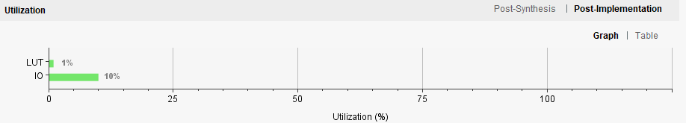

Figure 3: Resource Utilization Graph

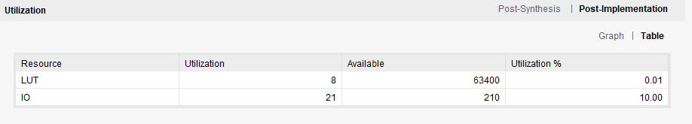

Figure 4: Resource Utilization Table

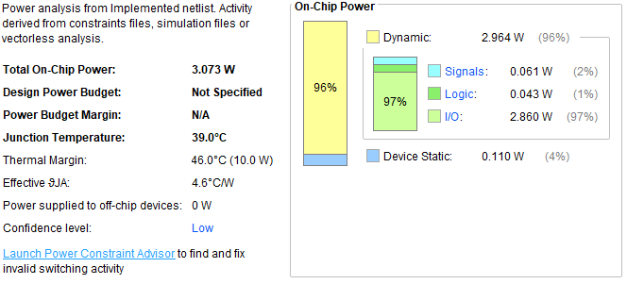

Figure 5: Power Usage